Andreas Landgrebe
October 16, 2014

1. A two paragraph commentary on the wrok that each team member completed.

2. An overview of how the sqlt-graph command-line options influence the resulting diagrams.

Inventory
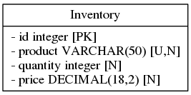

iTrust

NistDML181.png
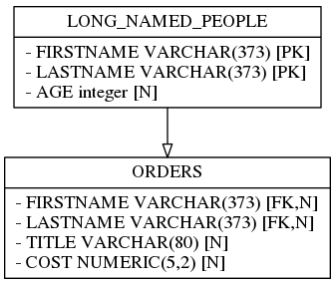

StackOverflow
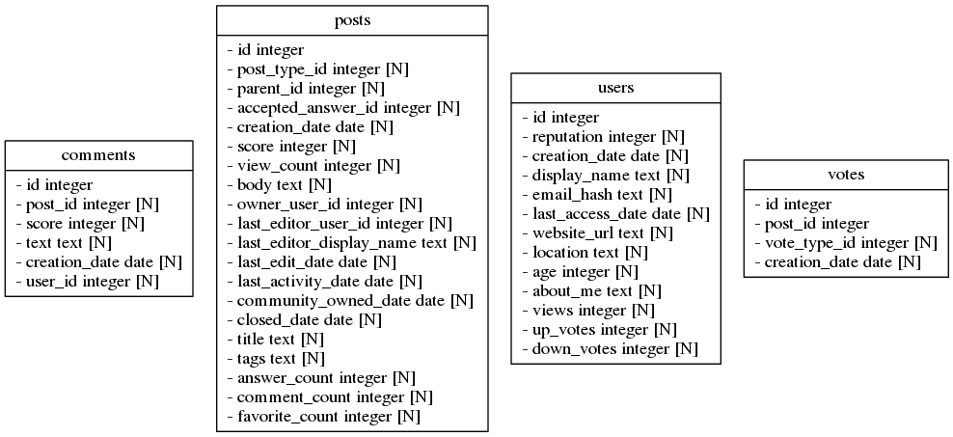

University
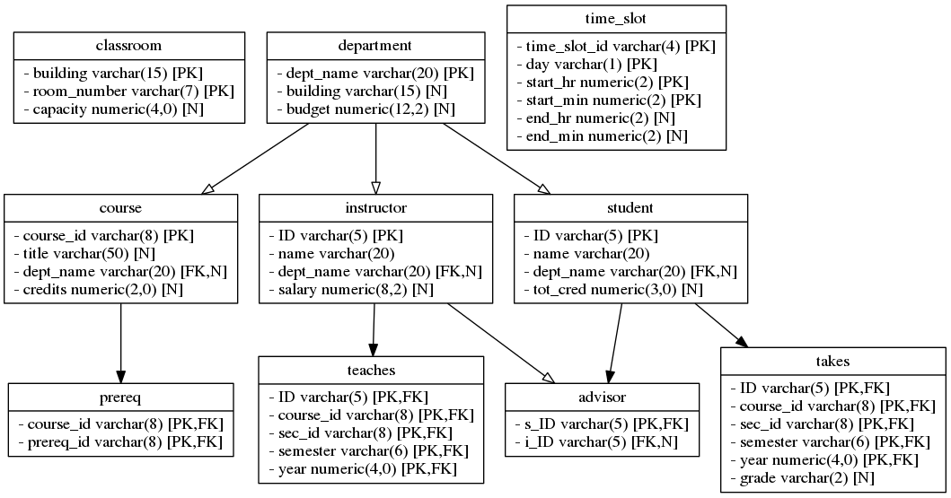

Unix Usage
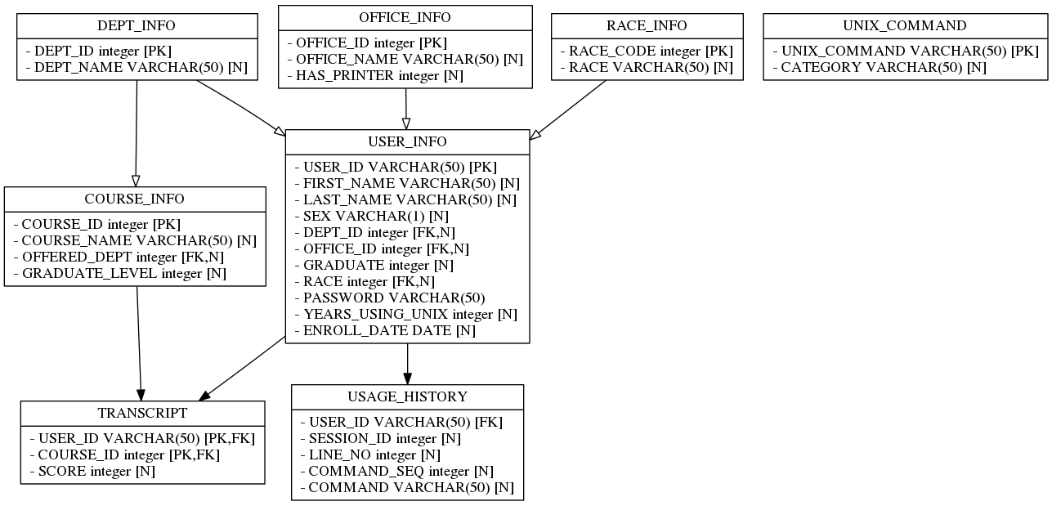

5. The complete and commented SQL source code for the student-designed relational schema.

CREATE TABLE Tournaments (
id INTEGER NOT NULL PRIMARY KEY, --ranking of player
id_tournament VARCHAR(15) NOT NULL, --this is grand slam tournament that the tennis player has played in
RESULT VARCHAR(4) --how well did the tennis player do in the tournament
);

CREATE TABLE Players (
id INTEGER NOT NULL PRIMARY KEY, --this will be the ranking of thye tennis player
first_name VARCHAR(15) NOT NULL, --first name of tennis player
last_name VARCHAR(15) NOT NULL, --last name of tennis player
country_of_origin VARCHAR(15) NOT NULL, --where the tennis player was born
FOREIGN KEY (id) REFERENCES Tournaments (id)
);

6. The final visualization of the student-designed relational schema, as produced by sqlt-graph
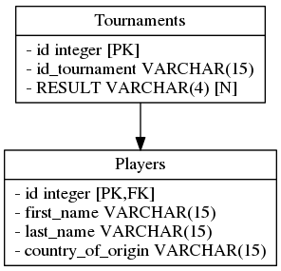
Players

7. A reflection on the challenges that you faced when completing this laboratory assignment.

